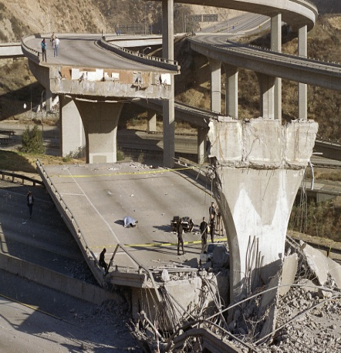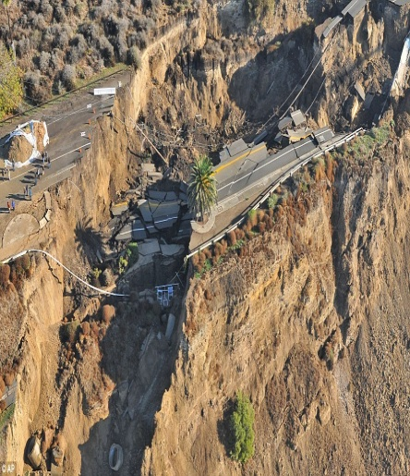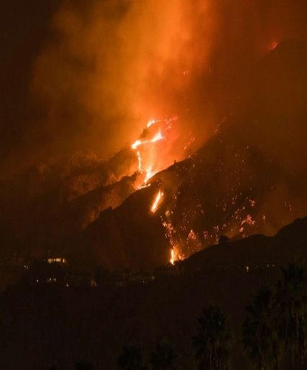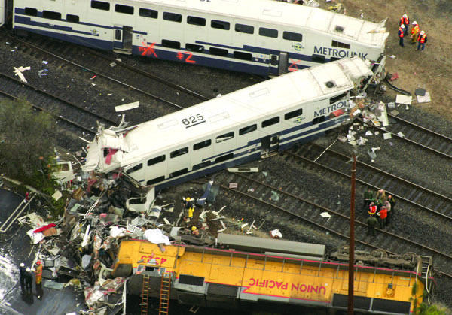

City of Los Angeles

Council District #

Emergency

Plan

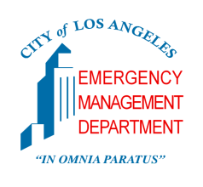Template Instructions:

1. Fill-in all areas in yellow.

2. Tailor this Plan to the unique characteristics of your district.

3. Update this Plan annually or when you have significiant staff turn over.

4. Make sure all staff understand this Plan or its will be useless!

(Remove instructions and tips in red.)

**2017**

**Table of Contents**

INTRODUCTION………………………………………………………………………………..3

The City of Los Angeles……………………………………………………………….3

Council District < # >…………………………………………………………………..3

Council District < # > Map………………………………………………………....….4

EMERGENCY READINESS AT THE OFFICE ………………………………………..…..5

Council District *< # >* Office……………………………………………………….….5

CONTINUITY OF OPERATIONS………………..……………………………………….…..6 During Normal Working Hours……………………………………………………......6

Outside Normal Working Hours………………………………………………...….....6

Council District Office Operations………………………...……………………….....7

Emergency Operations Center (EOC)………………………………………...….....7

Office of the Chief Legislative Analyst (CLA)………………………………...……..7

PUBLIC INFORMATION.………………………………………………………………….….8

Communicating with the Public………………………………………………...…….8

Information for the Community: Utilities.……………………………………...…….9

Information for the Community: Shelters……………………………………...…….9

Information for the Community: Reunification………………………………...…....9

STAFF ACTIVATION……………..…………………………………………………………..10

Phone Tree……………………..………………………………………………...……10

COUNCIL DISTRICT< # > STAFF ROSTER………………………………………...…….11

CITY EMERGENCY CONTACTS…………..……………….………………………...…….12

Council District *< # >* Fire Stations………………………………………………....12

Council District *< # >* Police Stations……………………………………………....12

ATTACHMENT A …………………………………………………………………………….13

Page numbers may change as you edit this Plan. Remember to change the page numbers as needed.

**INTRODUCTION**

The purpose of this Plan is to serve as a guideline in the event of a major emergency impacting or very likely to have an impact on Council District < # >. This document provides general background information regarding the role of the Council District Office during major emergencies during both normal working and non-working hours. Please keep an accessible copy of this document with you at all time.

**The City of Los Angeles**

The City of Los Angeles is the second most populous city in the United States. With more than 4 million residents and 400,000 businesses spread across 470 square miles, it represents more than 10 percent of California’s population. The city of Los Angeles is at risk of natural and man-made disasters of high consequence. Understanding and preparing for the threats facing the City of Los Angeles is a shared responsibility.

The Emergency Management Department (EMD) leads the City of Los Angeles in comprehensive emergency management including planning, preparedness, response, and recovery.

The City of Los Angeles has established the following operational priorities:

* Save lives and protect property
* Repair and restore essential systems and services
* Provide a basis for direction and control of emergency operations
* Provide for the protection, use and distribution of remaining resources
* Provide for continuity of government
* Coordinate operations with the emergency service organizations of other jurisdictions

**Council District Profile Data** < # >

*< Profile data of your district, consider including the following: >*

* *Demographics*
* *Council District boundaries*
* *Potential hazards. Visit - myhazards.caloes.ca.gov*
* *History of major emergencies*
* *Fire and Police stations within district boundaries*
* *Critical infrastructure* 
  + *Schools, hospitals, recreation areas, etc.*

**Council District** < # > **Map**

*Tips:*

* *You can include critical infrastructures in the map such as schools, fire stations, police stations, hospitals, government buildings…etc.*
* *Existing Council District maps can be found in this website:* [*http://lacity.cityofla.acsitefactory.com/city-government/elected-official-offices/city-council/map-districts*](http://lacity.cityofla.acsitefactory.com/city-government/elected-official-offices/city-council/map-districts)
* *Los Angeles GeoHub provides information that might be significant in your map. Check out: http://lahub.maps.arcgis.com/home/index.html*

*< Insert Council District Map >*

**EMERGENCY READINESS AT THE OFFICE**

Before an emergency happens, it is important that all staff be familiar with standing protocols and be prepared to assist in disaster relief.

**Council District** *< # >* **Office and Field Office**

All staff should be aware of the evacuation procedures and emergency supplies in each Council District *< # >* Office location.

CITY HALL

* Emergency evacuation map (Attachment #) *< attach office evacuation map >*
* First aid kits:
  + *< Where, inside the office, can staff locate first aid kits? >*
* Fire extinguishers:
  + *< Where, inside the office, can staff locate first aid kits? >*

*<FIELD OFFICE LOCATION #1>*

* Emergency evacuation map (Attachment #) *< attach office evacuation map >*
* First aid kits:
  + *< Where, inside the office, can staff locate first aid kits? >*
* Fire extinguishers:
  + *< Where, inside the office, can staff locate first aid kits? >*

*<FIELD OFFICE LOCATION #2> <add more locations as needed>*

* Emergency evacuation map (Attachment #) *< attach office evacuation map >*
* First aid kits:
  + *< Where, inside the office, can staff locate first aid kits? >*
* Fire extinguishers:
  + *< Where, inside the office, can staff locate first aid kits? >*

**CONTINUITY OF OPERATIONS**

During an emergency, it is critical that the Council District Office(s) maintain continuity of government operations and support recovery efforts. The recovery phase period will be based on the scale of the emergency. During this time, one of the main roles for Council District *< # >* is the continuity of constituent services and public information. Additionally, all Council District staff may be assigned to assist in response and recovery efforts during a disaster as Disaster Service Workers (DSW).

**During Normal Working Hours**

All staff should remain at work to make themselves available for disaster relief during normal working hours. However, if the emergency situation affects a staff member’s home or immediate family, talk to *< Council Member >* or *< Public safety Emergency Coordinator >*.

**Outside Normal Working Hours**

*Your office procedure must be decided by you. Here is a suggested method:*

If an emergency occurs outside normal working hours, all staff should attempt to contact their point of contact as indicated by the Phone Tree on page 10:

* *< Council Member > < Phone Number> < Alternate Phone Number>* or
* *< Chief of Staff > < Phone Number> < Alternate Phone Number>* or
* *< Public Safety < Phone Number> < Alternate Phone Number>  
  Emergency Coordinator.>*
* *< Alternate Public Safety < Phone Number> < Alternate Phone Number>  
  Emergency Coordinator.>*

It is the responsibility of all staff to make contact with one of the staff listed above to determine if he/she must report to work. All staff are expected to report to work at their normally scheduled time unless they are informed otherwise by their direct supervisor or *< Chief of Staff ?>*

**Council District Office Operations**

In the event Council District Office(s) is/are physically affected by a disaster, continuity of operations will resume from an alternate work site. If directed by *< Council Member >,< Chief of Staff >,* *< Public Safety Emergency Coordinator >,* *< Alternate Public Safety Emergency Coordinator >* all staff should be prepared to report to Council District *< # >*Office alternate work site:

*< Alternate Work Site>*

*< Alternate Work Site Address>*

*< Alternate Work Site Phone number>*

**Emergency Operations Center (EOC)**

During a citywide emergency, the Emergency Operations Center (EOC) will activate and become the focal point of coordination of the City’s response and recovery efforts. Council District *< # >* staff will NOT report to the EOC. During an activation, the Office of the Chief Legislative Analyst (CLA) serves as the Council’s Liaison in the EOC and monitors the situation.

**Office of the Chief Legislative Analyst (CLA)**

In the event of a large scale City emergency, the Office of the Chief Legislative Analyst will send a Notify Alert to the Council District Chiefs of Staff. A CLA representative will send periodic situation reports to Chiefs of Staff with information on EOC operations, disaster intelligence, and response activities.

The CLA representative can also assist with the coordination of specific assistance and services requests from the City Council offices.

The current CLA contact is: ____________________________ Phone: _____________

**PUBLIC INFORMATION**

**Communicating with the Public**

Due to the diverse nature of the district (age, language, culture, disability, technological knowledge, etc.) it is critical to use multiple methods of communication (person to person, television, radio, phone, text, email, website, social media notifications, Facebook event groups, community messaging boards, and other third-party channels) in an attempt to reach as many people as possible.

*< List any existing modes of communication that exist between the Council District Office and the public >*

All messages to the public must use easy to understand language and must use inclusionary language when referring to persons with disabilities or others with access and functional needs (DAFN).

*< List any pre-drafted messages that the Council District has established to be sent to their respective district in the event of a major emergency>*

It is important for all Council District *< # >* staff to understand that it is their responsibility to provide accurate information and not to speculate.

If a staff does not have the answer to a question, he/she must assure the constituent that he/she will respond to them as soon as possible with the accurate information.

**PUBLIC INFORMATION**

Potential issues that our Council District constituents may inquire about:

**Information for the Community: Utilities**

In a major emergency, it is likely that District *< # >* constituents and businesses will be without utility services and will need assistance. In the event constituents call for support, please refer them to the appropriate customer service utility providers:

*< List major utility service providers i.e. electricity, gas, water, telephone, etc. >*

*< Provide phone numbers that constituents can call and receive information about reestablishing utility services.>*

**Information for the Community: Shelters**

In the event of a disaster, the City of Los Angeles will set up shelters if the there is any potential threat to life and property in an affected area(s). Contact the CLA representative to identify open shelters and relay this information to District *< # >* constituents.

**Information for the Community: Reunification**

After a disaster, constituents may seek assistance locating their friends and family. List all platforms that your constituents could use to unite them with their friends and family.

Here are some suggestions:

* **Safe and Well website**

The “Safe and Well” website is a reunification tool created by Red Cross. Constituents can register themselves and search the list of those who have registered themselves as “Safe and Well.” The result of a successful search will display a loved one’s first name, last name and a brief message.

Constituents should be referred to: <https://safeandwell.communityos.org>

* **Facebook “Safety Check”**

Safety Check is a crisis response tool created by Facebook where Facebook users can mark themselves as “Safe” and help them connect with friends and loved ones during an emergency. Only individuals with Facebook account can use this tool.

**STAFF ACTIVATION**

*This is a suggested format and changes for every office. Make sure to include all your staff.*

In the event of an emergency, all staff should attempt to contact *< Council Member >, < Chief of Staff >*, or *< Public Safety Emergency Coordinator >*. However, *< Council Member >, < Chief of Staff >*, and *< Public Safety Emergency Coordinator >* will also attempt to communicate and notify any updates to all staff in the following manner.

**Phone Tree**

*< Council Member >*

**CLA**

*< Staff >*

*< Staff >*

*< Staff >*

*< Staff >*

*< Staff >*

*< Staff >*

*< Staff >*

*< Staff >*

*< Chief of Staff >*

*< Public Safety Emergency Coordinator >*

**COUNCIL DISTRICT** *< # >* **STAFF ROSTER**

*< List all Council district office staff. Include: >*

* *Name*
* *Title*
* *Phone number*
* *Alternate phone number / cell phone*
* *Consider: Home phone number*
* *Name*
* *Title*
* *Phone number*
* *Alternate phone number / cell phone*
* *Consider: Home phone number*
* *Name*
* *Title*
* *Phone number*
* *Alternate phone number / cell phone*
* *Consider: Home phone number*
* *Name*
* *Title*
* *Phone number*
* *Alternate phone number / cell phone*
* *Consider: Home phone number*
* *Name*
* *Title*
* *Phone number*
* *Alternate phone number / cell phone*
* *Consider: Home phone number*
* *Name*
* *Title*
* *Phone number*
* *Alternate phone number / cell phone*
* *Consider: Home phone number*

**CITY EMERGENCY CONTACTS**

Council District *< # >* staff should call 911 for life safety matters. The below contacts are for critical important information sharing and updates.

City Hall Operator (available from 8:00 am – 4:45 pm daily)………………………...….311

Outside the greater Los Angeles area………………………………....213-473-3231

EOC Liaison Agency Representative CLA…………………….……………...213-576-6462

EMD (Main Line)…..……………………………………............…………….…213-484-4800

EMD Duty Officer…..……………………………………............…………….…213-200-6414

Metro Fire Communications (24-hours)…………………………………….….213-576-8900

LAPD Media Relations & Public Communications Section………..…...……213-486-5930

LAPD (Non-Emergency)…………………………………………………..…..877-ASK-LAPD

**Council District** *< # >* **Fire Stations**

*< Include contact information for local fire stations >*

**Council District** *< # >* **Police Stations**

*< Include contact information for local police stations >*

**ATTACHMENT A**

**COUNCIL DISTRICT SAFETY ASSESSMENT**

(Fill-in below as appropriate)

In the event of a major disaster, Council District staff may use this form to perform rapid damage assessments of their perspective District. The Council District may then contact the appropriate authorities to report or check the status of any identified damages.

**Disaster/Emergency Name:** ______________________________________________

**[Date] From:** __________________________ To: ____________________________

**Hazard:** _______________________________________________________________

**Potential Magnitude** (Percentage of the District that can be or is affected):

**Catastrophic:** More than 50%

**Critical:** 25 to 50%

**Limited:** 10 to 25%

**Negligible:** Less than 10%

**Affected Area(s)** _______________________________________________________

______________________________________________________________________

**Damages:**

Private Infrastructure Damage Infrastructure Type: _____________________

Public Infrastructure Damage Infrastructure Type: _____________________

Downed Trees Running Water Out of Session Schools

Downed Power Lines Smell/Hear Gas Vacant Businesses

No Electricity Fire Vacant Homes

No Phone Reception Smoke Blocked Driveways

No Public Transit Broken Sidewalks Other

**Notes**___________________________________________________________________________________________________________________________________________________________________________________________________________________________________________________________________________________

**Assess Critical Facilities:**

* Schools __________________________________________________________  
   _________________________________________________________________
* Hospitals _________________________________________________________  
   _________________________________________________________________
* Nursing Homes ____________________________________________________  
   _________________________________________________________________
* Fire Station _______________________________________________________  
   _________________________________________________________________
* Police Station ______________________________________________________  
   _________________________________________________________________
* Government Buildings _______________________________________________  
   _________________________________________________________________
* Bridges/Freeways __________________________________________________  
   _________________________________________________________________
* Other ____________________________________________________________  
  _________________________________________________________________

**Council District Comments/Recommendations:** _____________________________ ____________________________________________________________________________________________________________________________________________

______________________________________________________________________

**Reported By:** __________________________________________________________

**Date/Time:** ____________________________________________________________

**Follow-Up Agency if Needed**

* CLA  Police Fire  Animal Services  Public Works  Other ___________

**Recommendations/Comments** ______________________________________________________________________

________________________________________________________________________________________________

________________________________________________________________________________________________